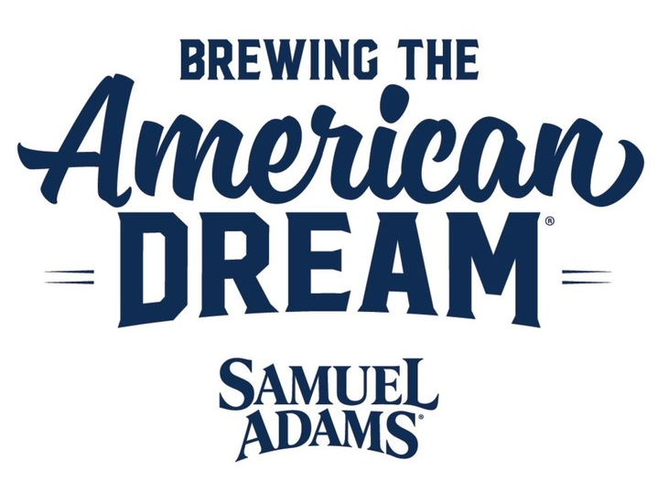
Samuel Adams Showcases Over 15 Years of Small Business Support with the Launch of Inaugural “Our American Dream Cookbook”

80 Inspiring Food & Beverage Entrepreneurs Come Together in a First-of-its-Kind Culinary Guide to be Published by Salty Days Media Company on October 1st, 2024

BOSTON, MA – Samuel Adams Brewing the American Dream, the revolutionary philanthropic program aimed at providing mentorship and funding to food and beverage entrepreneurs nationwide, is pleased to announce the launch of Our American Dream Cookbook.

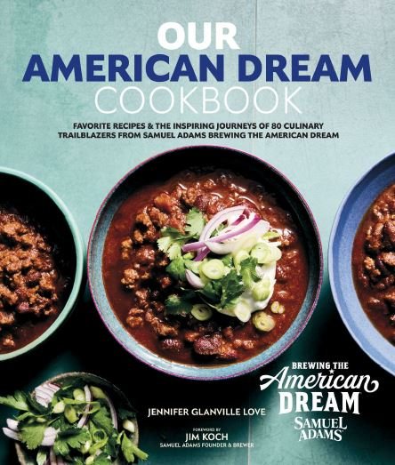
Our American Dream Cookbook not only celebrates 40 years since Jim Koch ignited the craft beer revolution with Samuel Adams, but also brings to life over 15 years of work done by Brewing the American Dream to uplift passionate craftspeople across the country. With 100+ must-try dishes, the cookbook accomplishes a first-time achievement of featuring recipes developed by 80 small business owners. In these pages, culinary trailblazers share their unique stories of inspiration and resilience.

A versatile spectrum of recipes for beer lovers and foodies alike makes way for specialties such as Vegan Onion Soup with Beer from a veteran-owned brewery on the West Coast, New England Lobster Rolls from artisanal salt makers on the shores of Massachusetts, Lemon Raspberry Celebration Cake with Vanilla Buttercream from the very first participant in the program, and much more.

From cover to cover, this collection showcases the magic that sparks when the lived experiences and passions of small business owners are given the spotlight. Cooks of all skill levels are warmly invited to explore family-secret comfort food, plant-forward picks, seasonal favorites with a twist and much more–along with perfect pint pairings from the folks that know craft beer the best.

“It’s been my privilege all these years working with Brewing the American Dream to see firsthand the power, vision and determination of our country’s brightest food and beverage entrepreneurs. I’m so honored to help tell the incredible stories of just a fraction of the thousands of craftspeople we’ve welcomed into our family,” said Jennifer Glanville Love, author and director of partnerships & collaborations at Boston Beer Company. “We all have a dream we would chase if given the opportunity and we make it our mission to ensure that every entrepreneur brave enough to take that leap has all of the resources they need. Our deepest hope is that each recipe within this book leaves the reader with a full belly, an even fuller heart and the inspiration to do what they love.”

Early praise for the cookbook includes:

Elle Simone Scott, founder of SheChef, food stylist, and culinary producer: “When someone decides to make an entrepreneurial venture, it comes with a lot of excitement but also a lot of uncertainty. Samuel Adams Brewing the American Dream has become a cornerstone in the food and beverage industry, helping crafters and creators find the answers to the questions. They bring ease and expertise to the process.”

Kevin Johnson, co-founder of National Black Brewers Association, brewery owner, and former NBA all-star: “As an athlete turned brewery owner, I know the dedication and courage it takes to pursue your dreams. I’ve seen firsthand the work Brewing the American Dream does to celebrate craft food and beverage businesses and this cookbook takes that to a new level. Every recipe represents a fusion of passion and collaboration, showcasing the entrepreneurial spirit of small business owners alongside the rich flavors of craft beer. A winning combination for any culinary enthusiast!”

More than an exciting new cookbook, this body of work is an invitation to fill the dining table with fresh energy, diversity, and the abundance of flavor woven into the tapestry of our country’s food and beverage landscape.

Our American Dream Cookbook will officially launch on October 1st, 2024 and is available to pre-order now at Amazon, Barnes & Noble, Books-A-Million, Bookshop and independent bookstores across the nation. Our American Dream Cookbook is distributed to the trade by Simon & Schuster Distribution Services. For more information about bulk sales, please contact S&S Customer Service at 1-800-223-2336 or customerservicebiz@simonandschuster.com

To learn more about Brewing the American Dream and the resources it offers small business owners, visit www.brewingtheamericandream.com

About Brewing the American Dream
Since 2008, Samuel Adams has supported its nonprofit lending partners in providing over 4,300 loans totaling more than $107 million to food and beverage entrepreneurs. Just as important, the program has provided business coaching and advising to more than 15,000 people. The businesses supported by this program have created or retained more than 11,500 jobs in their local communities.

About Boston Beer Company
The Boston Beer Company, Inc. (NYSE: SAM) began in 1984 brewing Samuel Adams beer and the Samuel Adams brand is currently recognized as one of the largest and most respected craft beer brands. Our portfolio of brands also includes Truly Hard Seltzer, Twisted Tea, Angry Orchard Hard Cider, Dogfish Head Brewery, and Hard Mountain Dew, as well as other craft beer brands such as Angel City Brewery and Coney Island Brewing. For more information, please visit our investor relations website at bostonbeer.com, which includes links to all of our respective brand websites.

About Salty Days Media
Salty Days Media is a publishing start-up bringing together the most talented culinary book creators and is committed to partnering with esteemed brands and entrepreneurs to craft captivating books that inspire audiences and foster consumer engagement. Through our unwavering dedication to storytelling, experiences, and pure joy, Salty Days Media endeavors to deliver quality content that resonates with a global audience.
Why we embrace Salty Days: In ancient Rome, salt epitomized abundance and vitality. Today Salty Days means sharing cherished moments brimming with flavor, enticing aromas, and emotion. As Sara Domville says, “Salty Days Media celebrates life’s adventures, transforming everyday moments into extraordinary memories.” It commemorates life’s remarkable adventures and, in this case, from the inception of Salty Days Media to the unveiling of Our American Dream, the inaugural book, available everywhere where books are sold. To learn more about Salty Days Media Company contact Sara Domville at saradomville@saltydays.com or visit www.saltydays.com

###

